Build and Release Management

Lab

DATE: 28-01-21

NAME: RAJUL DUBEY

SAP ID: 500069424

ROLLNo.: R171218081

TASKS

1.) Configure git in Eclipse IDE

2.) Install Jenkins and run it

**Task 1->**

i) Open Eclipse

ii) right click on a project you made or create one

iii) now go to team

iv) go to share project

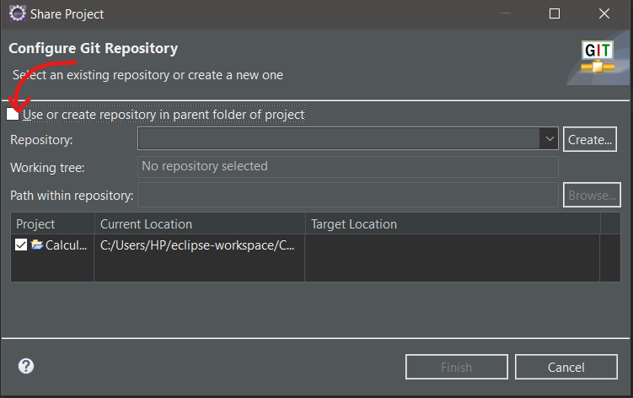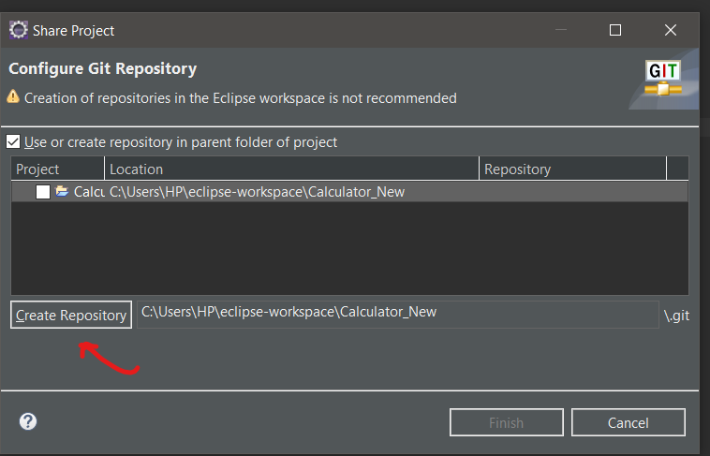

vi.) now again go teams and click on *commit,push* option

vii.) Now stage the files and commit them

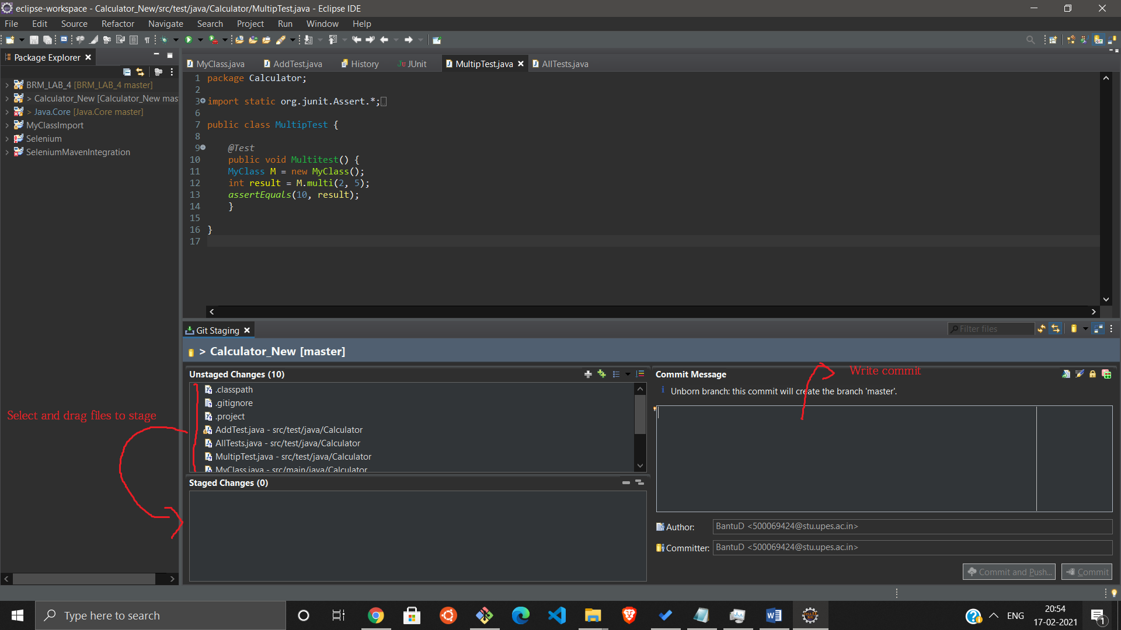

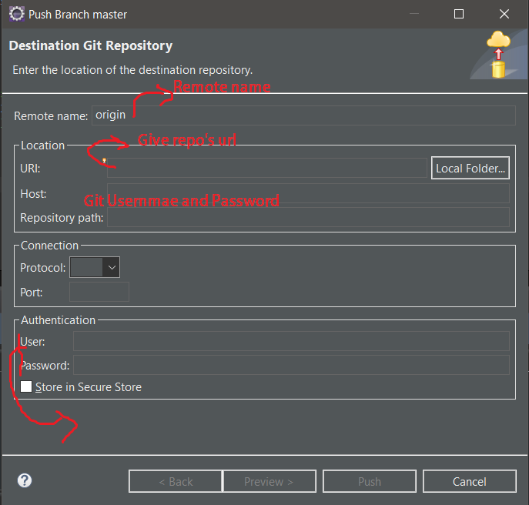

viii.) Fill the fields and push commit.

**Task->2**

i.) Download Jenkins from (<https://www.jenkins.io/>)

ii.) Install it

iii.) Now run command line as

Administrative

vi.) Now goto Jenkins installation folder

through command line

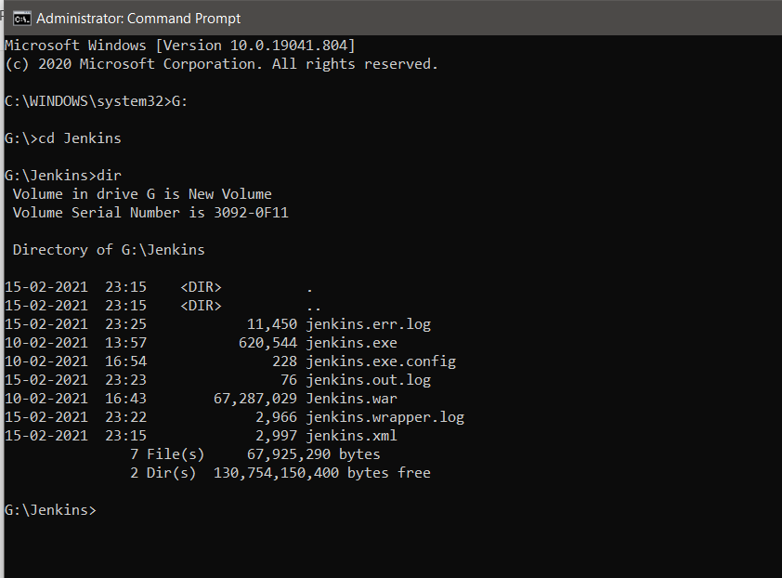

vii.) Now run Jenkins.war file

Sysntax:

java –jar Jenkins.war

viii.) When Jenkins will fully startup it

will show something like this

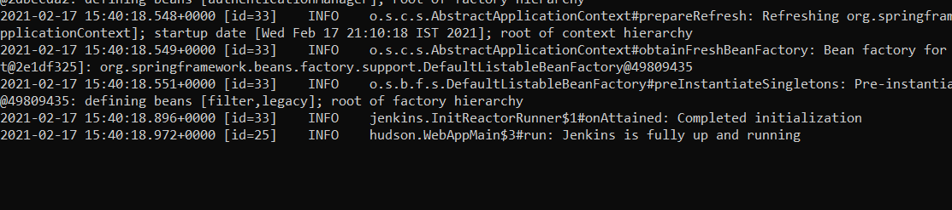

xi.)Now open <http://localhost:8080/>

in your browser give default password which will be in shown in cmd and configure JDK,Maven,Git,.etcs plugins as required.